Day 1:

Docs -> <https://docs.google.com/document/d/1cz8EO5hKwwCOR8UFMqjdphafrZwVfgEXj9pCRvazPBU/edit?tab=t.0>

Data

<https://s3.amazonaws.com/sankethadoop/u.data>

# Lab 1: first spark code

data = [("Ram", 30), ("Shyam", 25), ("Mahadev", 35)]

columns = ["Name", "Age"]

df = spark.createDataFrame(data, columns)

df.show()

filtered_df = df.filter(df.Age > 28)

filtered_df.show()

# Lab 2: **Read data from Control plane, DBFS and S3**

# Read data from Control plane

df = spark.read.option("delimiter", "\t").csv("dbfs:/Workspace/Users/dheeraj.sain@thinknyx.com/data/ds1.data", inferSchema=True)

df.show()

df = df.withColumnRenamed("_c0", "user_id") \

.withColumnRenamed("_c1", "movie_id") \

.withColumnRenamed("_c2", "rating") \

.withColumnRenamed("_c3", "timestamp")

df.show()

df.groupBy("rating").count().orderBy("rating").show()

# Read data from DBFS

"""

this is basically a layer top of s3 storage in more optimized way, and i am not getting the option to connect is because i haven't connected my databricks with the aws.

"""

# Read data from S3

df = spark.read.option("delimiter", "\t").csv("s3a://sankethadoop/u.data", inferSchema=True)

df = df.withColumnRenamed("_c0", "user_id") \

.withColumnRenamed("_c1", "movie_id") \

.withColumnRenamed("_c2", "rating") \

.withColumnRenamed("_c3", "timestamp")

df.show()

df.groupBy("rating").count().orderBy("rating").show()

Day 2:

Lab 3: Installing Data

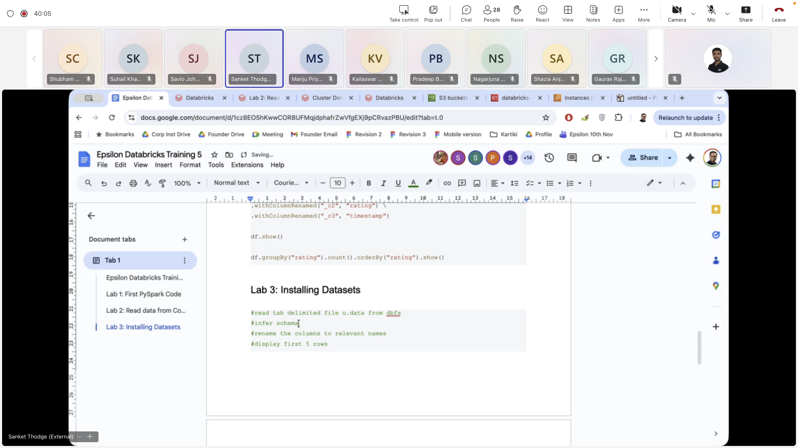

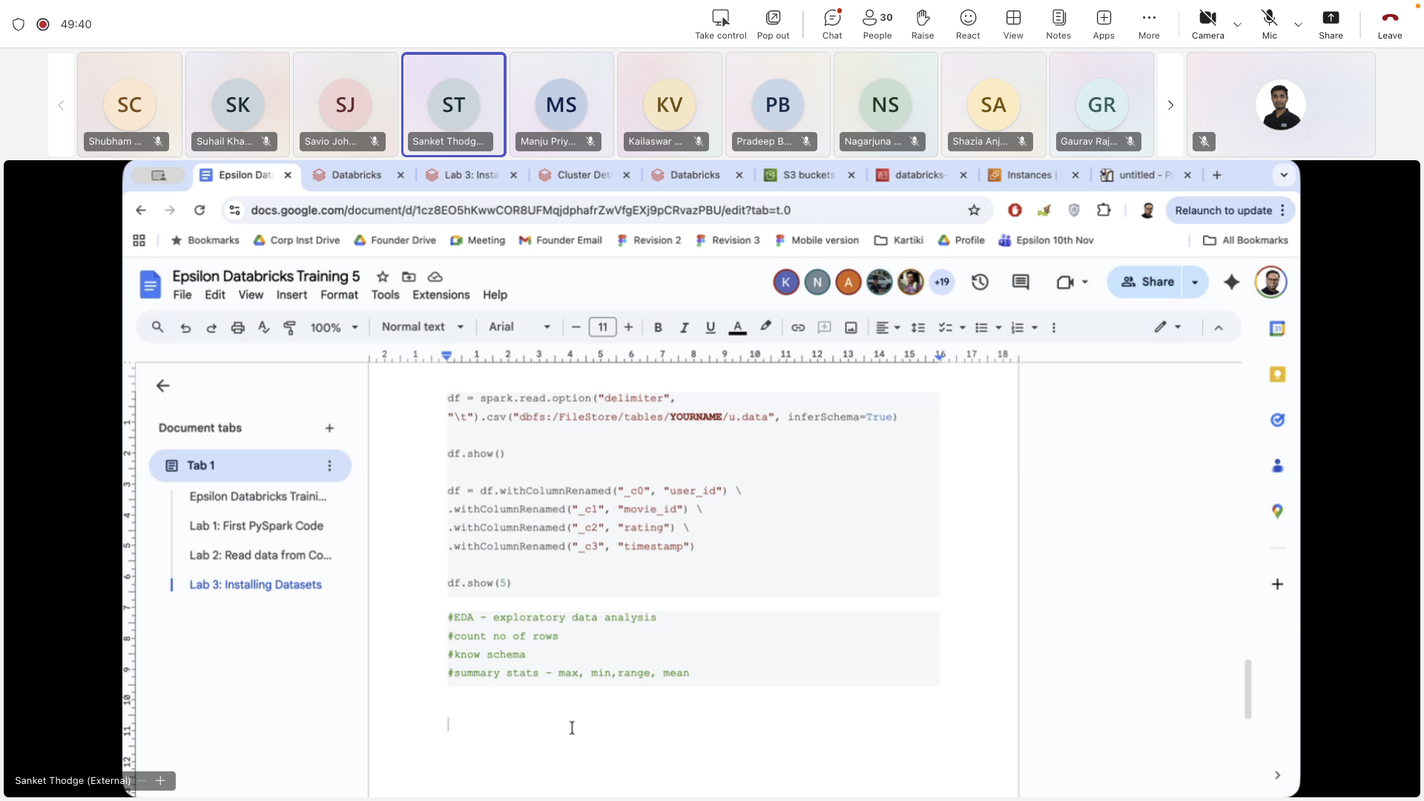

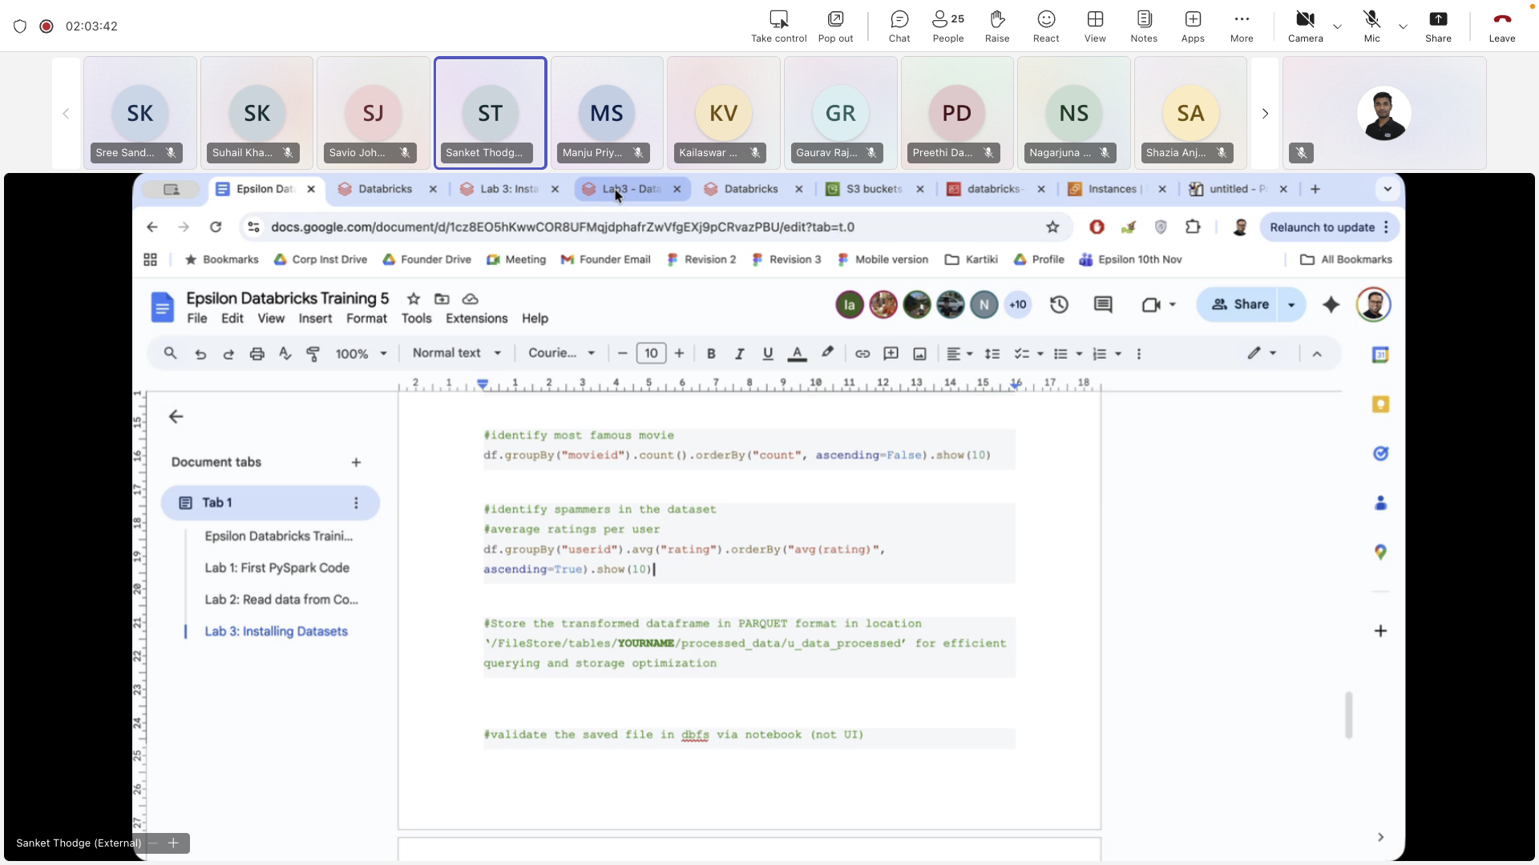

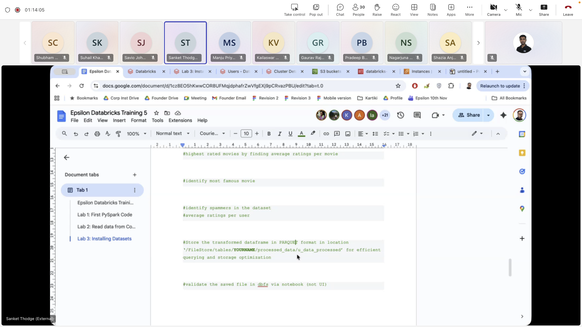

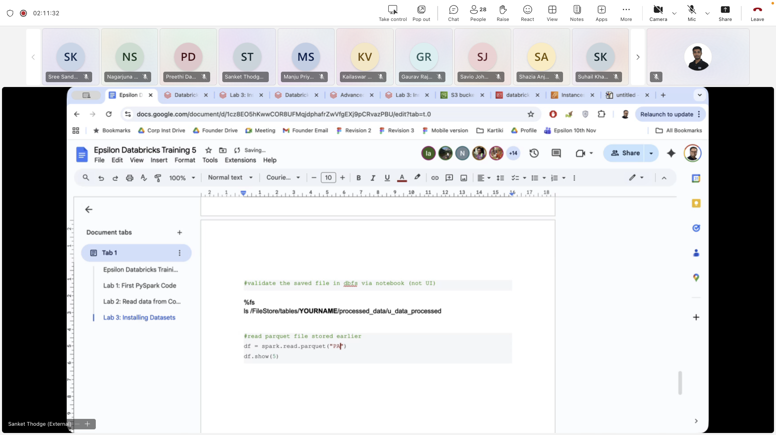

**Lab 4: Magic Commands**

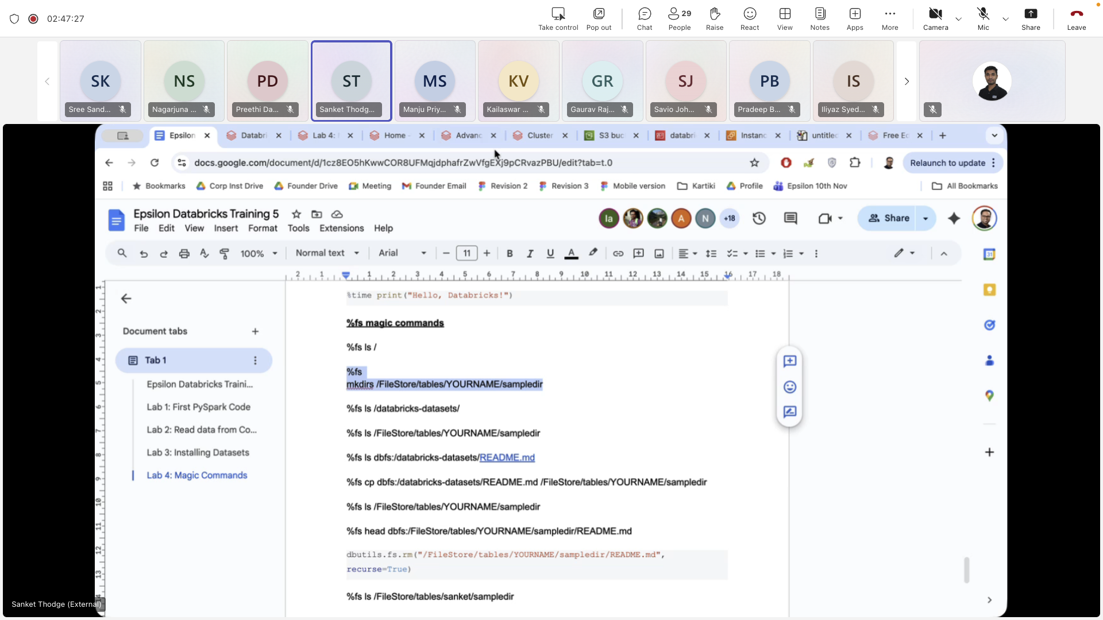

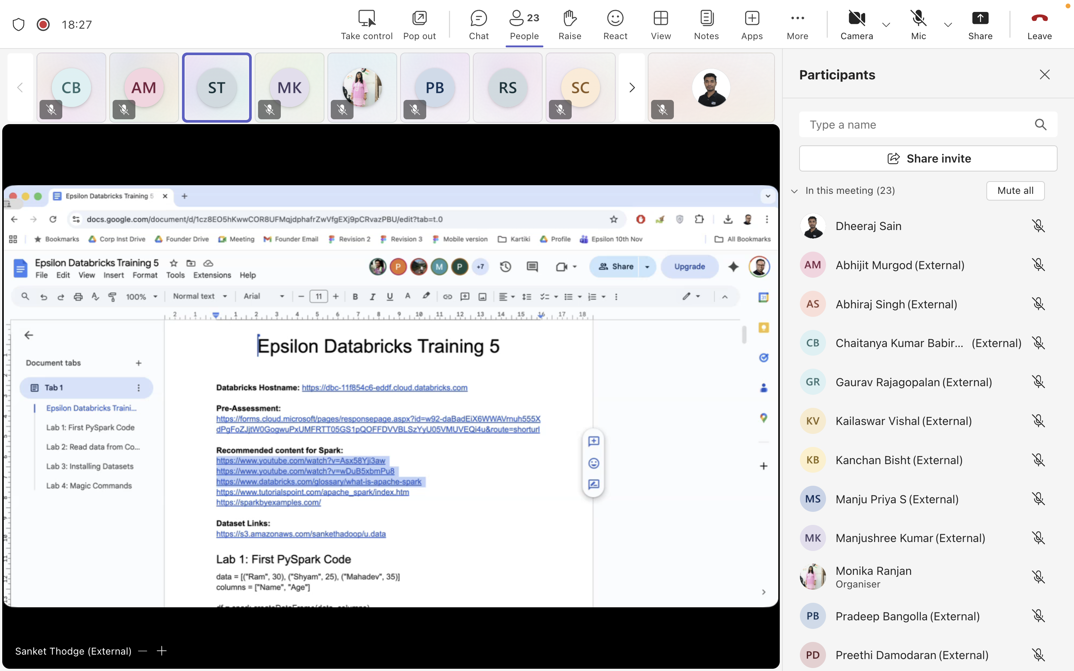

**Day 3:**

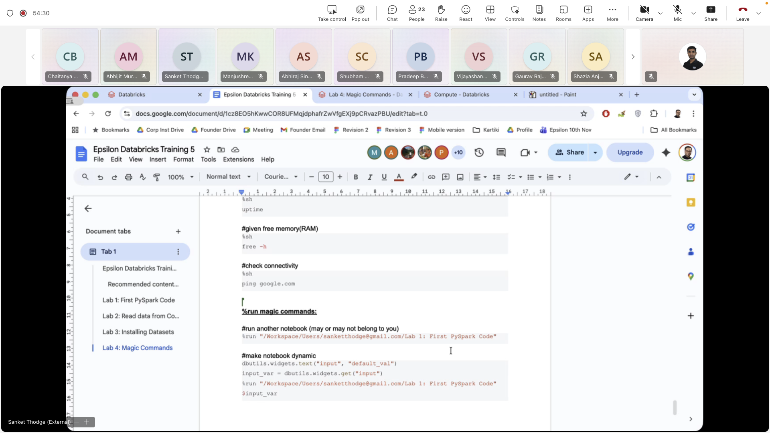

**Lab 5:**

**Lab 6: Databricks and Spark SQL fundamentals**

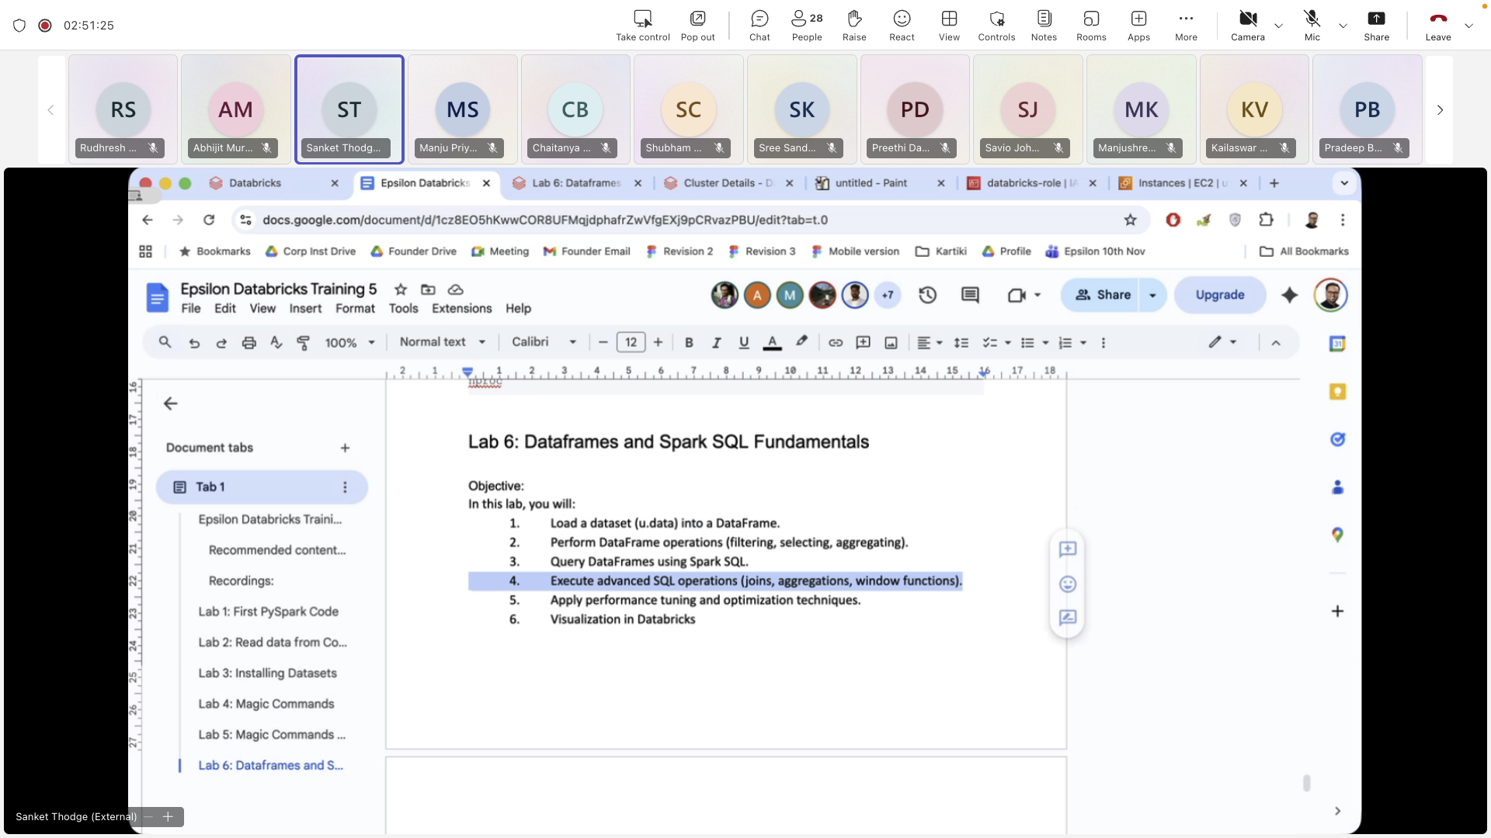

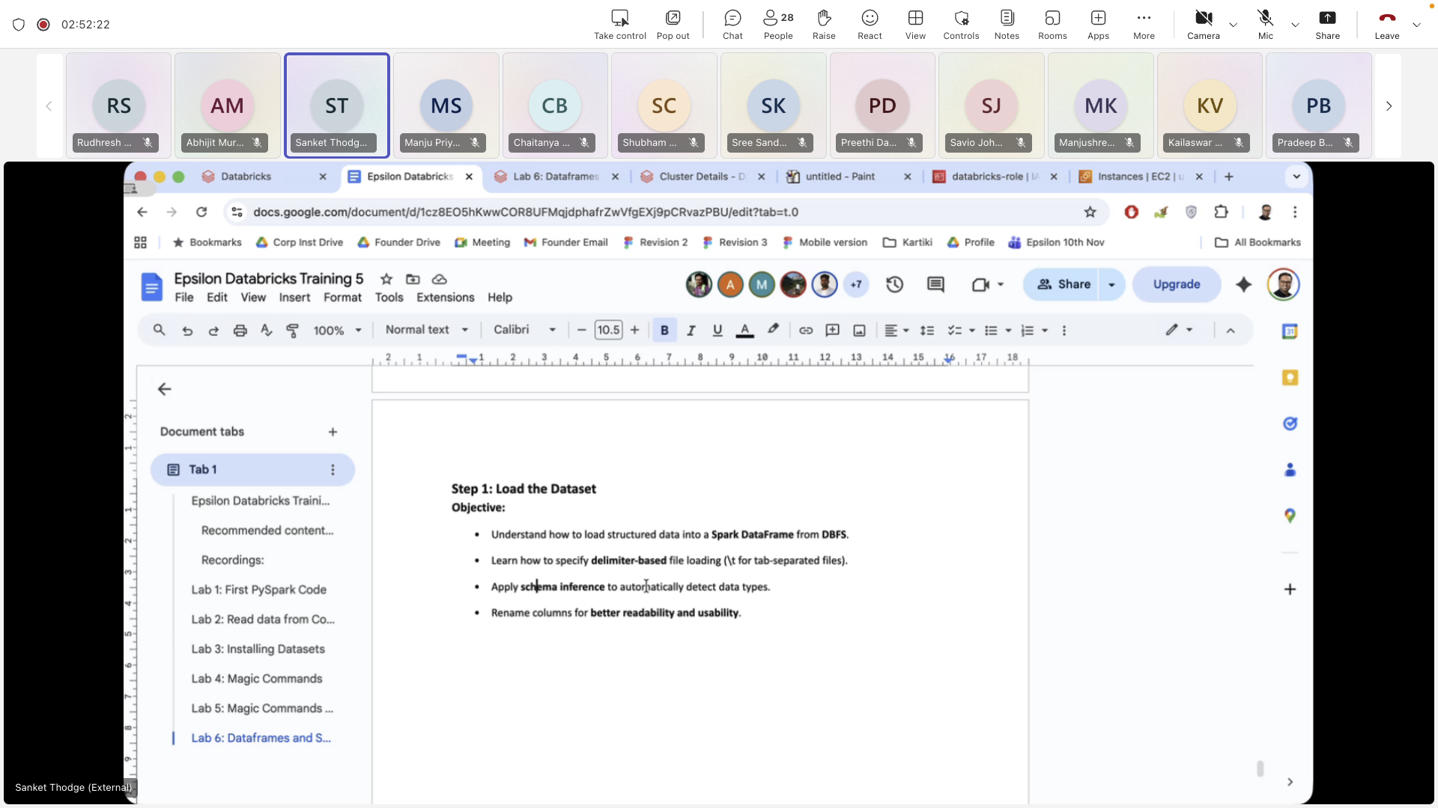

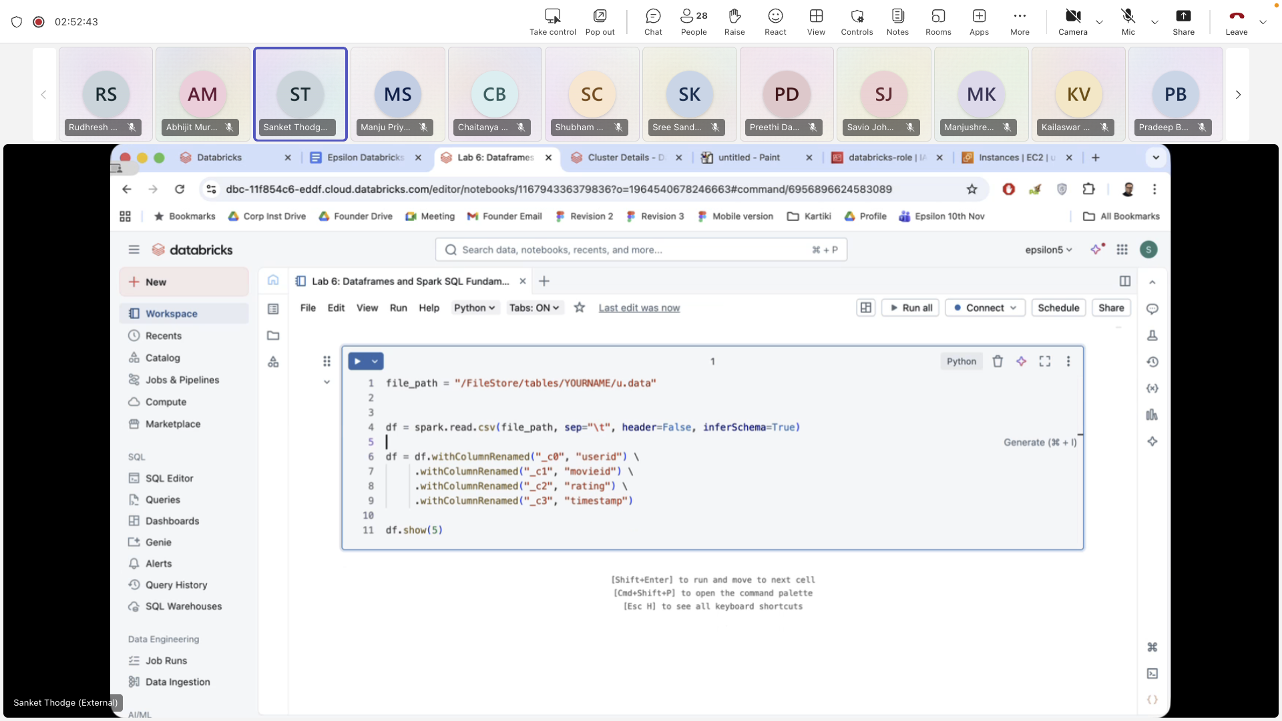

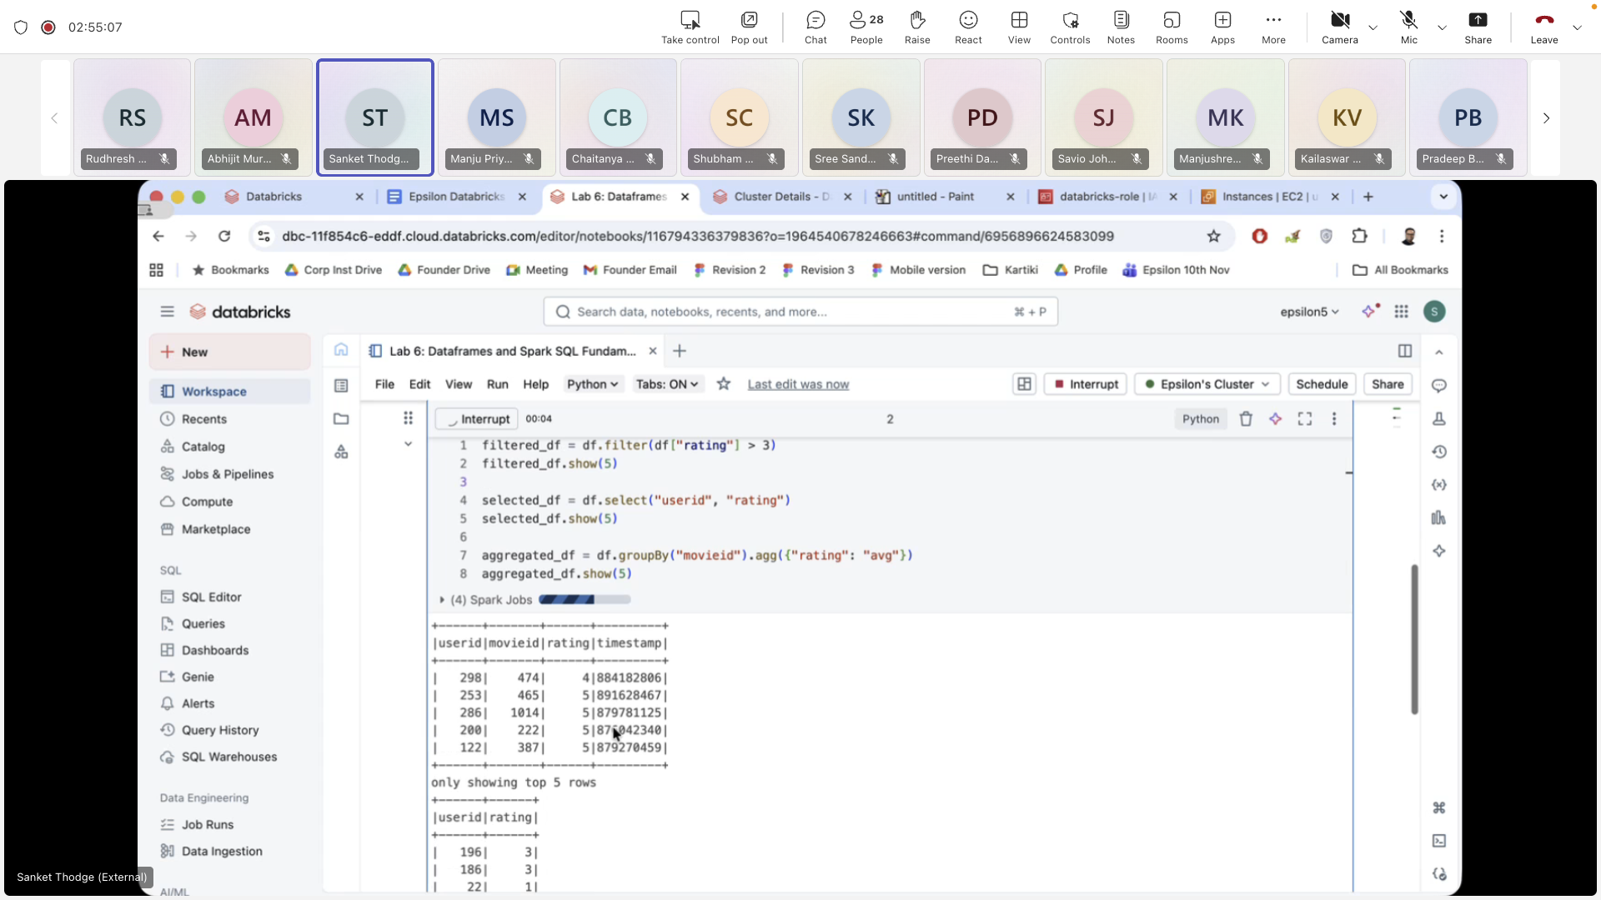

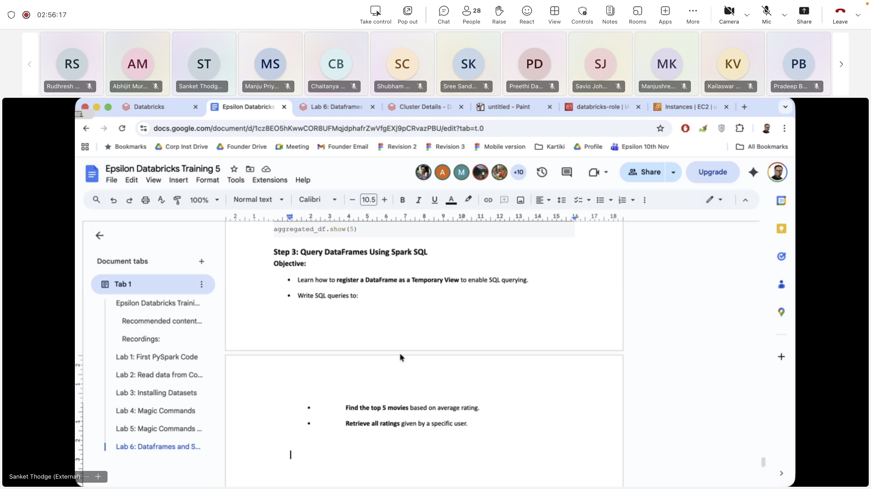

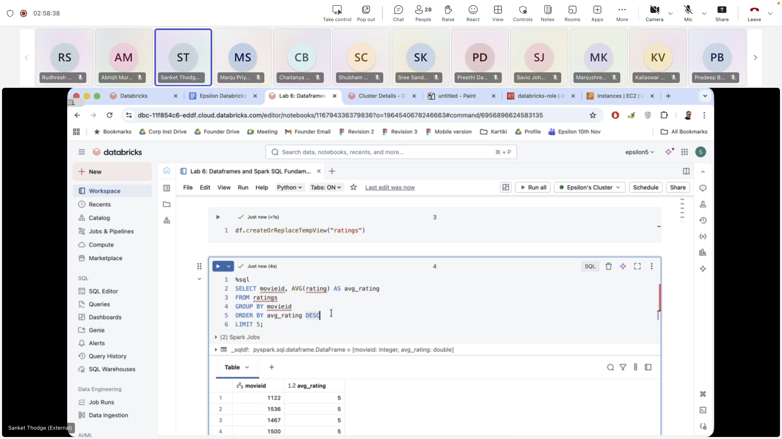

**Day 4:**

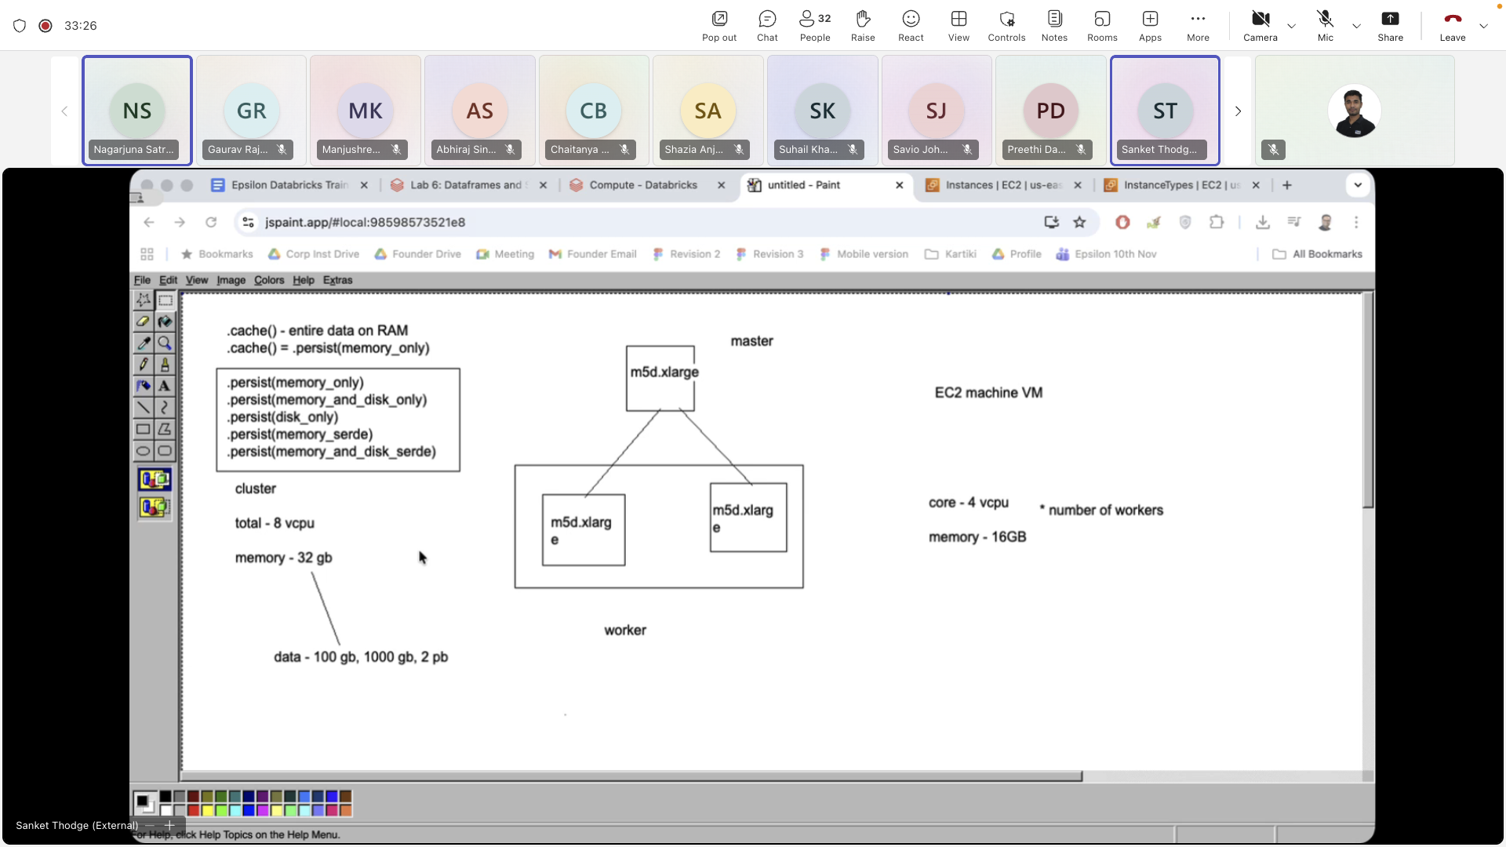

**Lab 7:**

<https://s3.amazonaws.com/sankethadoop/fakefriends.csv>

<https://s3.amazonaws.com/sankethadoop/customer-orders.csv>

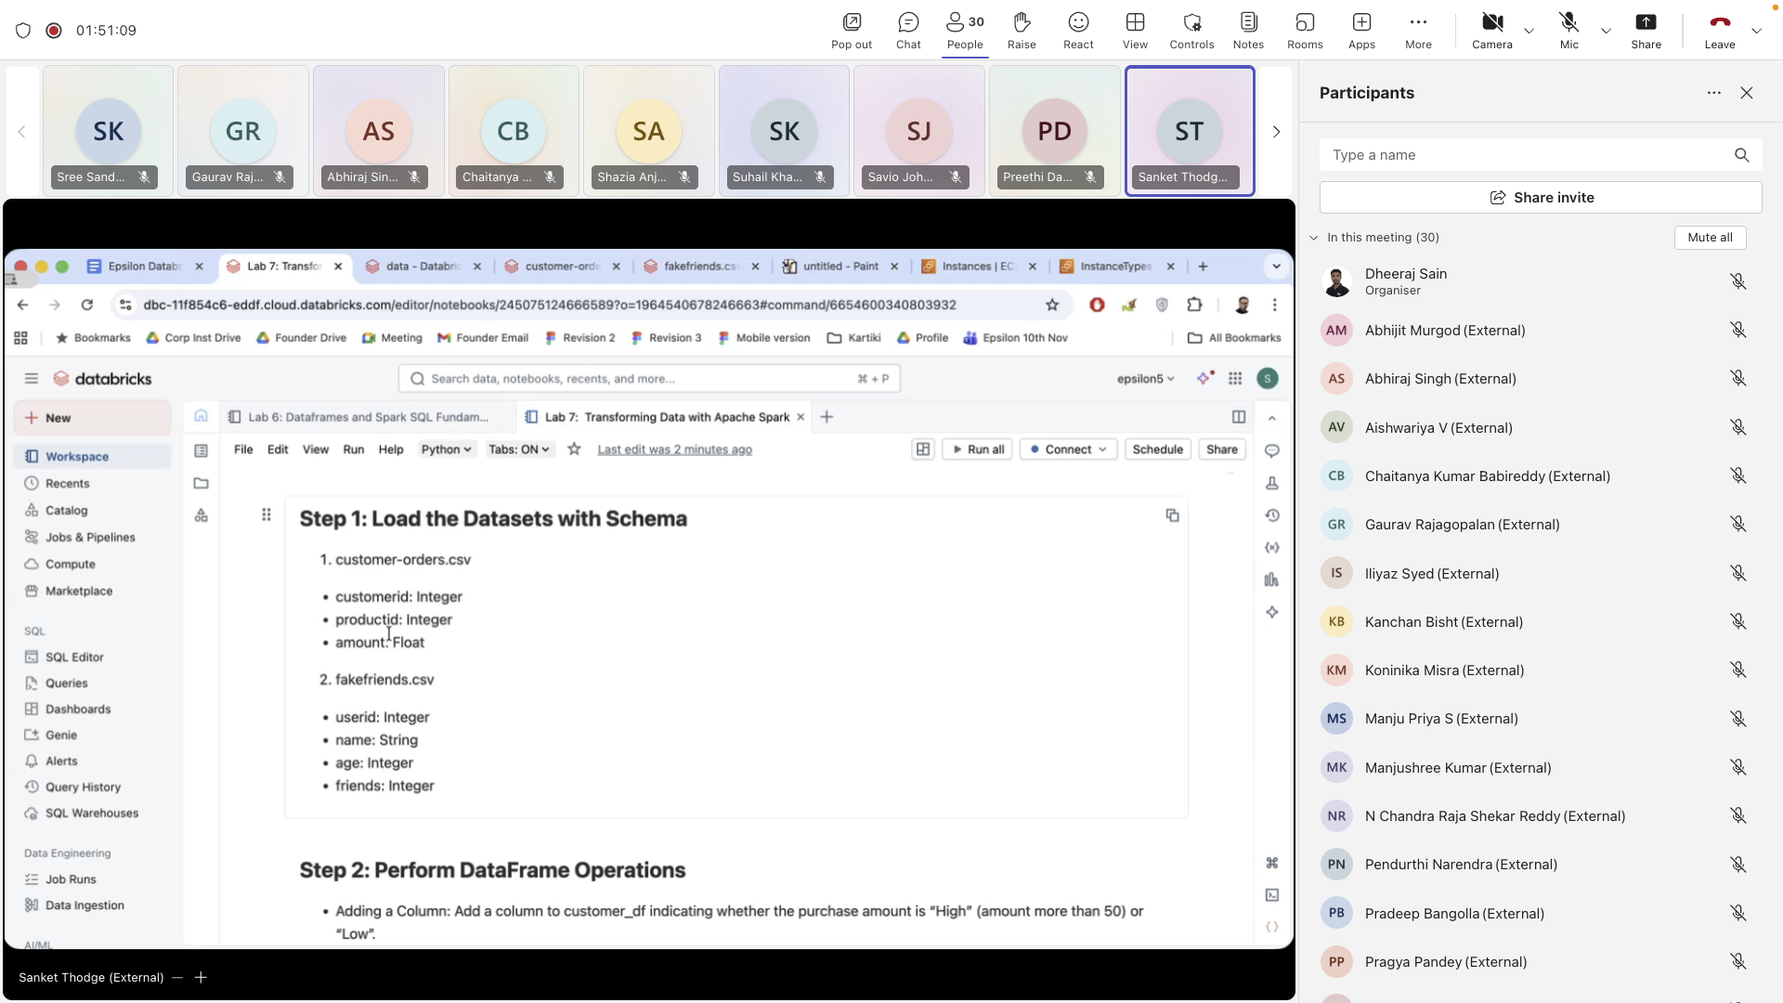

Based on the image you've shared, it looks like you are working with Spark in Databricks and need to load datasets with their schema. Here are a few example questions and tasks related to this:

### 1. **Loading the Datasets with Schema**

* **Question**: How would you load the customer-orders.csv and fakefriends.csv datasets into a Spark DataFrame using the schema provided?
* **Task**: Write the code to load the customer-orders.csv and fakefriends.csv datasets into Spark DataFrames in Databricks, ensuring that the schema is applied correctly for each dataset.

**Example Code** (in Databricks with PySpark):

from pyspark.sql.types import sc dei FloatType, StringType

# Define schema for customer-orders.csv

customer_orders_schema = StructType([

StructField('customerid', IntegerType(), True),

StructField('productid', IntegerType(), True),

StructField('amount', FloatType(), True)

])

# Load customer-orders.csv with schema

customer_orders_df = spark.read.csv('/path/to/customer-orders.csv', header=True, schema=customer_orders_schema)

# Define schema for fakefriends.csv

fakefriends_schema = StructType([

StructField('userid', IntegerType(), True),

StructField('name', StringType(), True),

StructField('age', IntegerType(), True),

StructField('friends', IntegerType(), True)

])

# Load fakefriends.csv with schema

fakefriends_df = spark.read.csv('/path/to/fakefriends.csv', header=True, schema=fakefriends_schema)

### 2. **Querying the Datasets**

* **Question**: After loading the datasets, how would you query to find the total spending by each customer from the customer-orders.csv dataset?
* **Task**: Write a query in Spark SQL or PySpark that calculates the total spending (amount) per customer from the customer-orders.csv dataset.

**Example Query**:

# Register DataFrames as temp tables to run SQL queries

customer_orders_df.createOrReplaceTempView("customer_orders")

# Query total spending by customer

total_spending_df = spark.sql("""

SELECT customerid, SUM(amount) AS total_spending

FROM customer_orders

GROUP BY customerid

ORDER BY total_spending DESC

""")

total_spending_df.show()

### 3. **Joining Datasets**

* **Question**: How would you join the two datasets (customer-orders.csv and fakefriends.csv) based on a related field, like customer ID or user ID, to get a combined view of customer spending and their friends?
* **Task**: Write the code to perform a join between customer-orders.csv and fakefriends.csv on the relevant field.

**Example Code**:

# Assuming user ID in fakefriends matches customer ID in customer-orders

joined_df = customer_orders_df.join(fakefriends_df, customer_orders_df.customerid == fakefriends_df.userid, "inner")

# Show the result

joined_df.show()

### 4. **Aggregating and Analyzing the Data**

* **Question**: How would you find out the average number of friends for each customer in the fakefriends.csv dataset?
* **Task**: Write a code to calculate the average number of friends for each customer.

**Example Code**:

# Calculate the average number of friends

average_friends_df = fakefriends_df.groupBy("userid").agg({"friends": "avg"})

# Show the result

average_friends_df.show()

### 5. **Saving the DataFrame**

* **Question**: After performing analysis, how would you save the result into a new CSV file or a different format like Parquet?
* **Task**: Write the code to save the resulting DataFrame to a new CSV or Parquet file.

**Example Code**:

# Save the result to a CSV file

total_spending_df.write.csv('/path/to/output/total_spending.csv', header=True)

# Or save it as a Parquet file

total_spending_df.write.parquet('/path/to/output/total_spending.parquet')

**Lab 8: UDF**

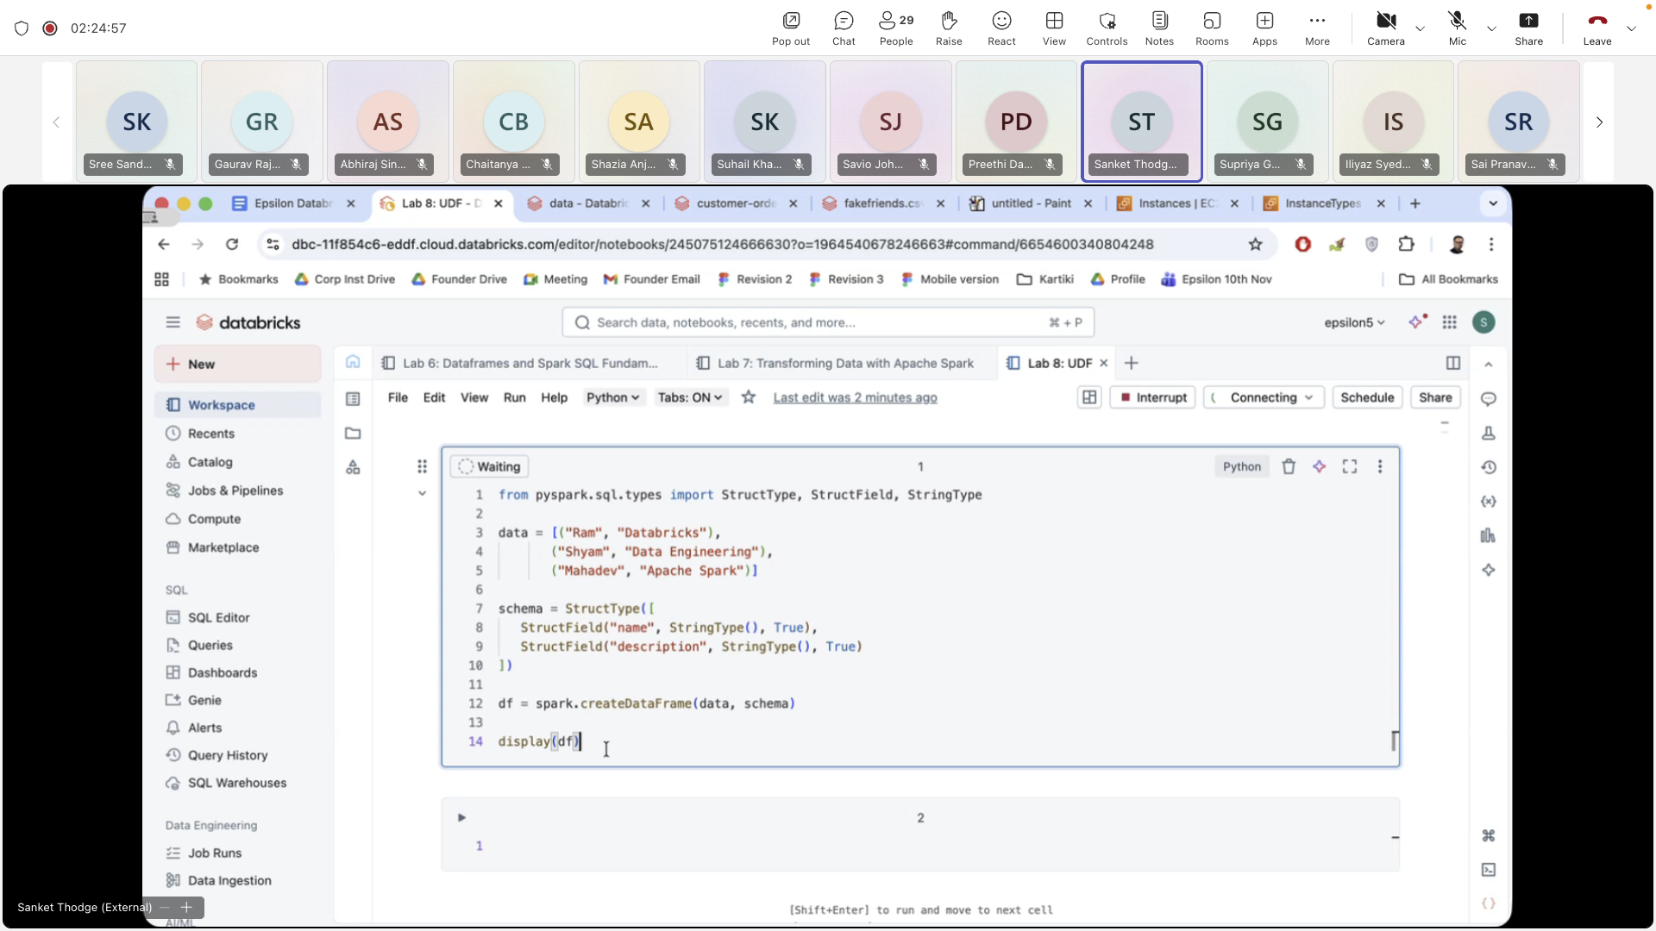**u**

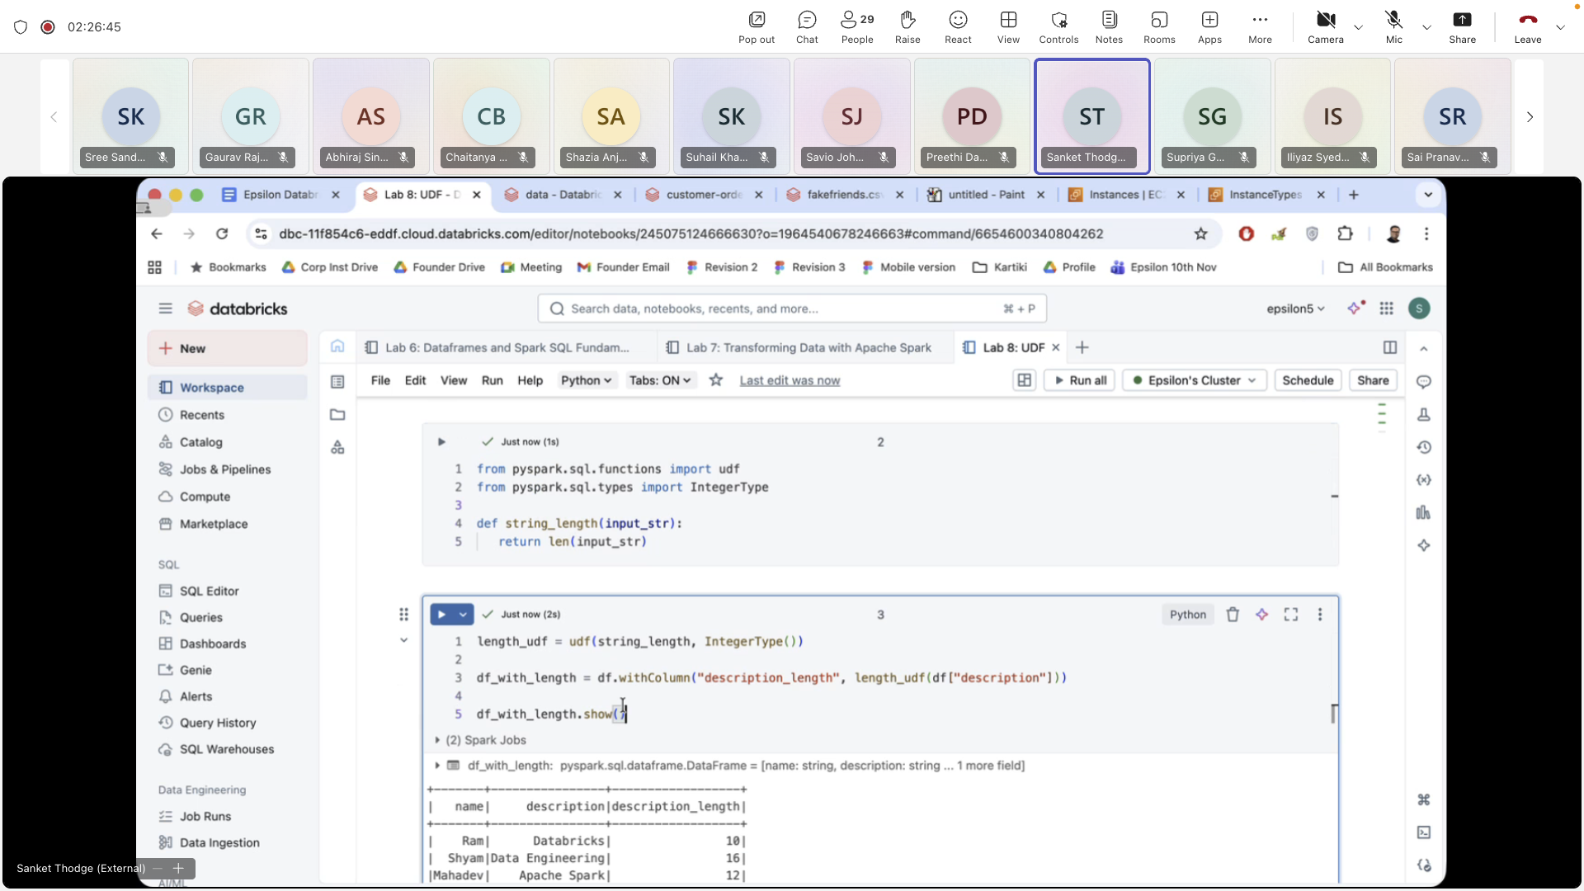

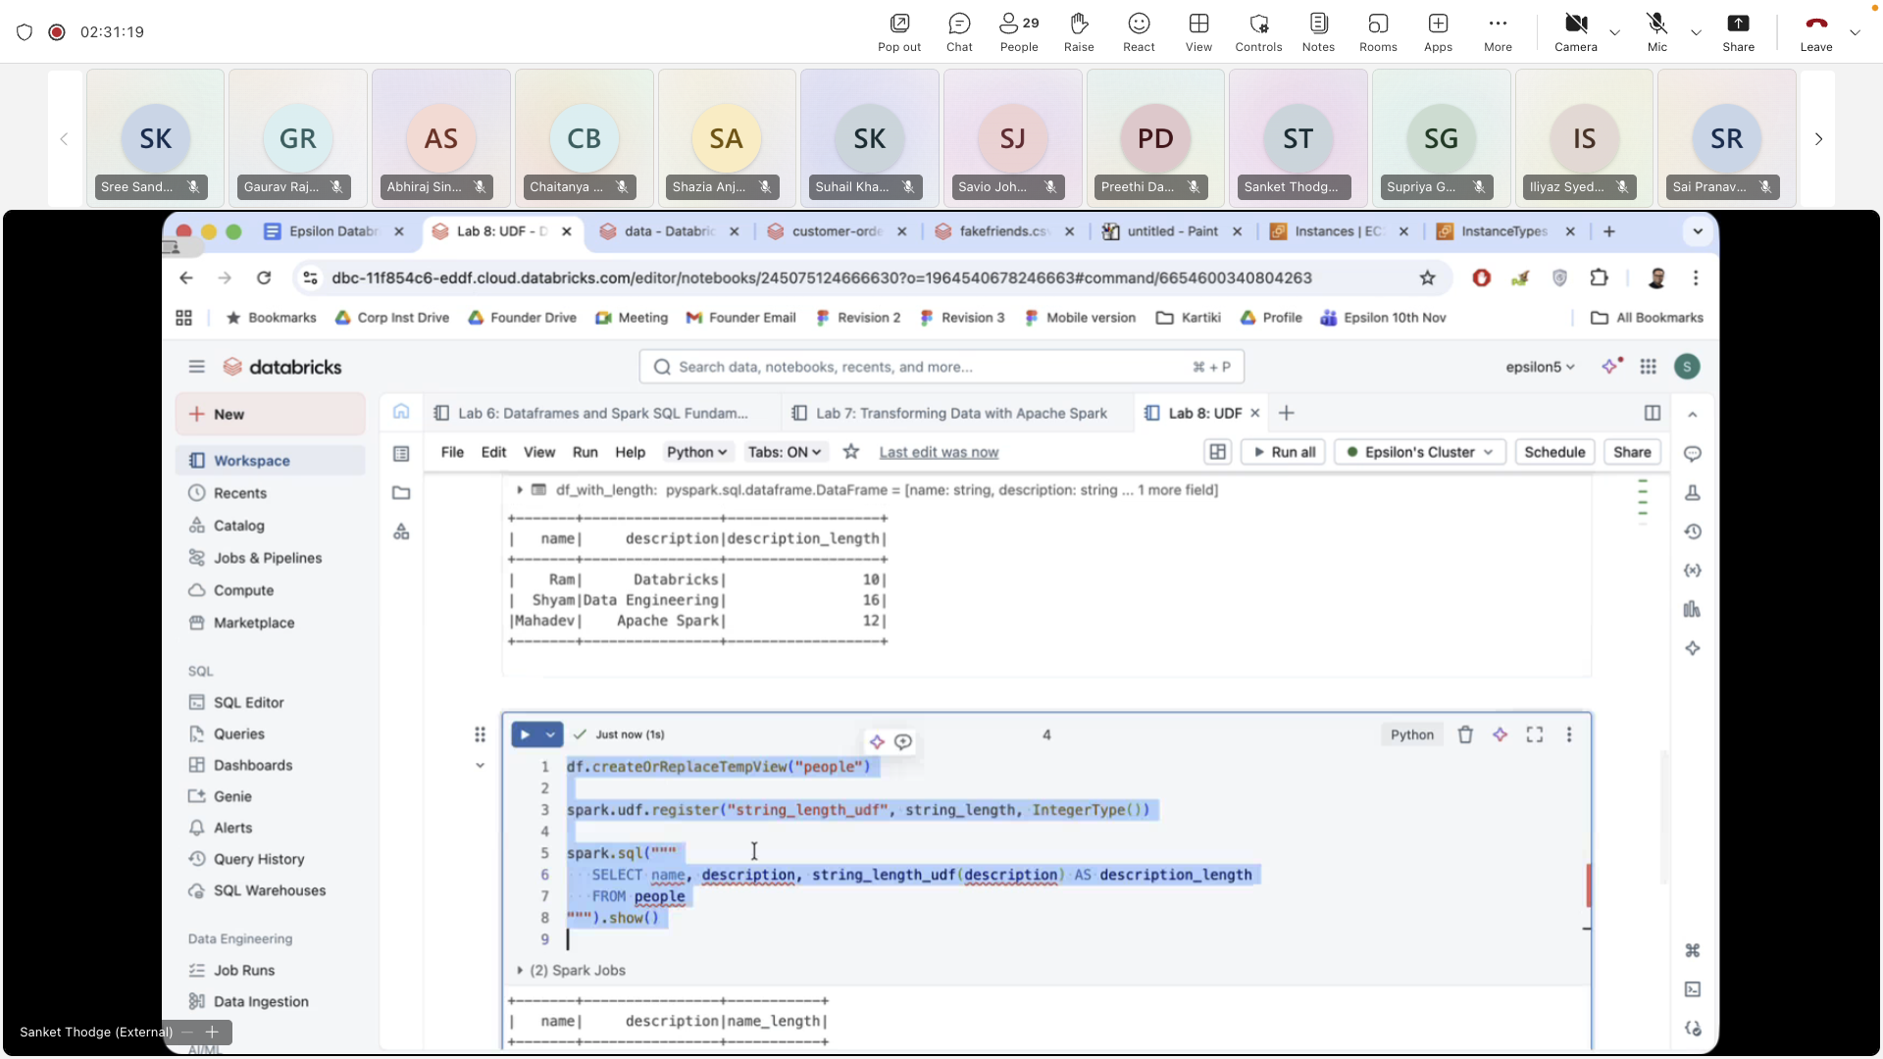

**LAB 9:**

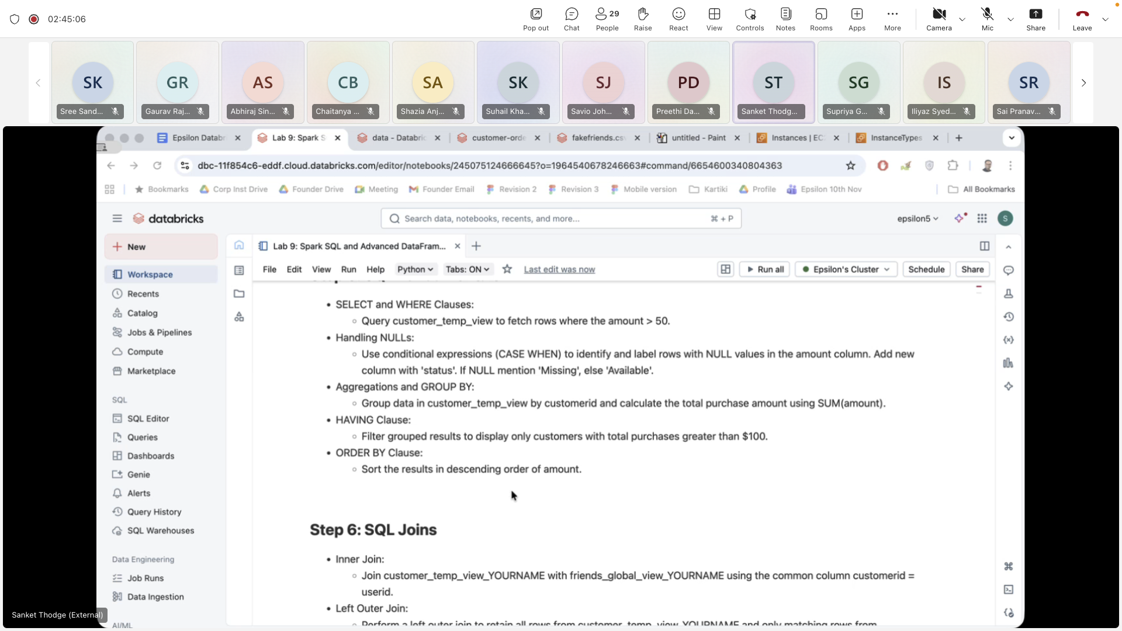

**Day 5:**

**Lab 10.1: Medallian Architecture with Databricks workflow**

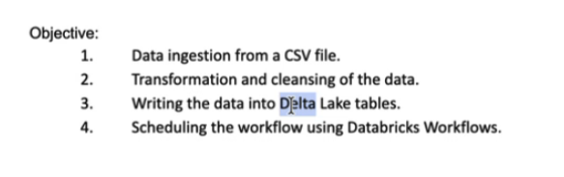



<https://s3.amazonaws.com/sankethadoop/Batting.data>

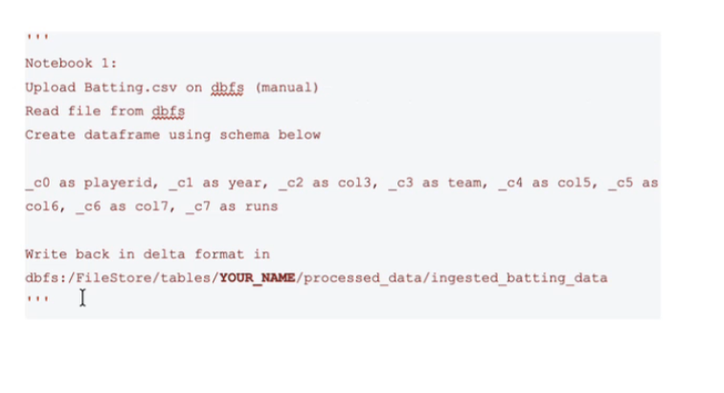

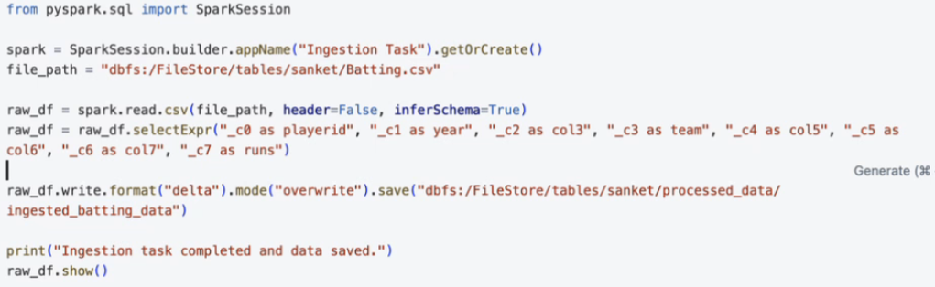

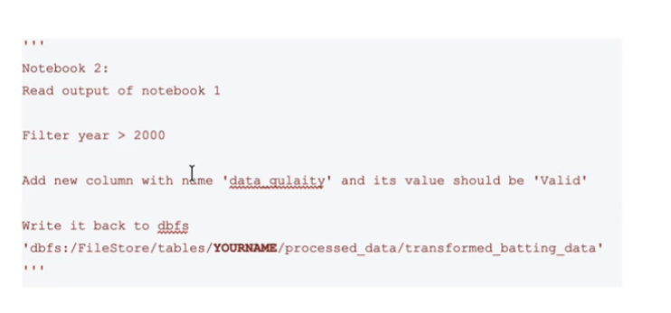

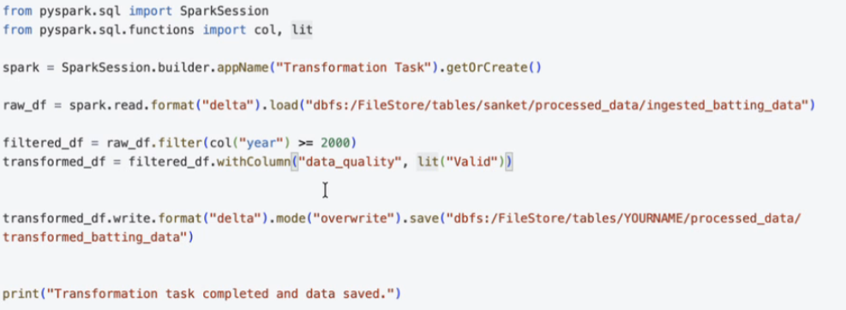

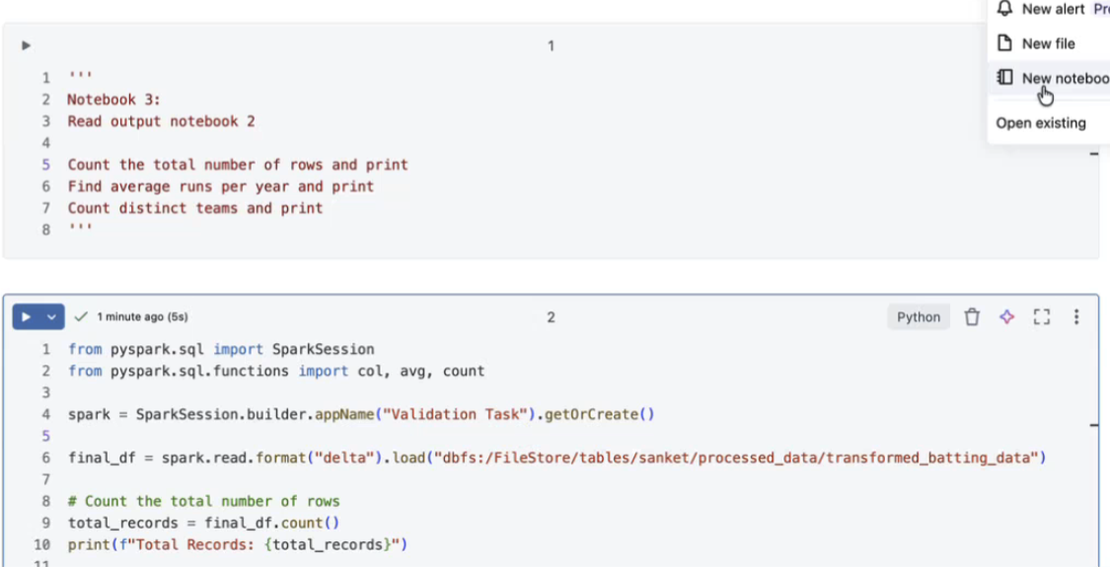

**Day 6:**

**lab 12: Delta lake**

**Data:**

https://s3.amazonaws.com/sankethadoop/u.data

https://s3.amazonaws.com/sankethadoop/customer-orders.csv

https://s3.amazonaws.com/sankethadoop/fakefriends.csv

https://s3.amazonaws.com/sankethadoop/Batting.csv

https://s3.amazonaws.com/sankethadoop/All_States_PinCode.csv

read pincode.csv file and store it back in delta format at below location: dbfs:/FileStore/tables/YOURNAME/delta|pincode_data_YOURNAME

schema - all string, except pincode being integer

OFFICE_NAME

OFFICE_STATUS

PINCODE

TELEPHONE

TALUK

DISTRICT

STATE

POSTAL_DIVISION

POSTAL_REGION POSTAL_CIRCLE

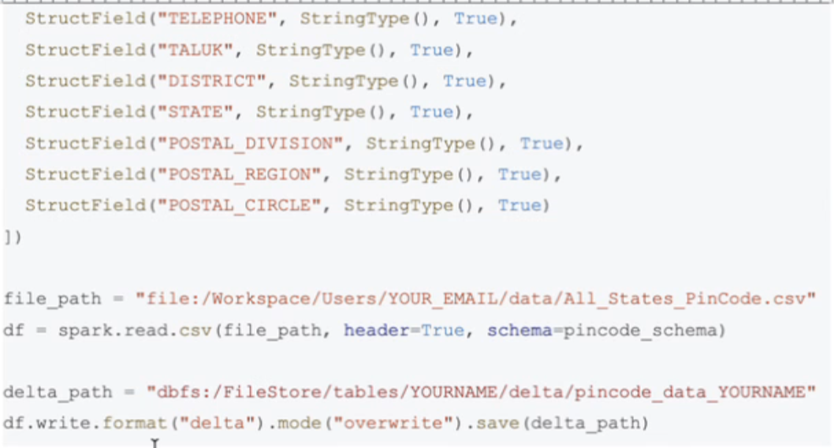

#Register the data on dois as a table - pincode_data_YOURNAME

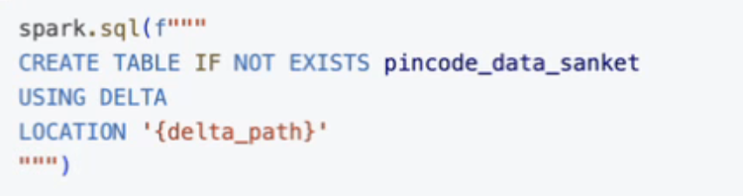

Another way:

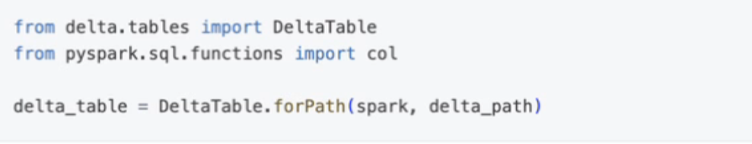

#inserting data into delta table

#check table for #incode '999999' exist or not, if it doesn't create

dataframe with write schema and insert it into the table

#verify the data post insertion

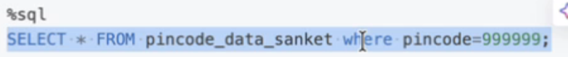



#modify data in the table for office status column

#check what values you have in khat folumn

#change office status to 'head office' for pincode 110001

#verify the modified values in the table



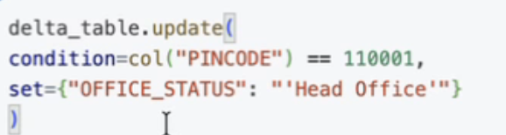



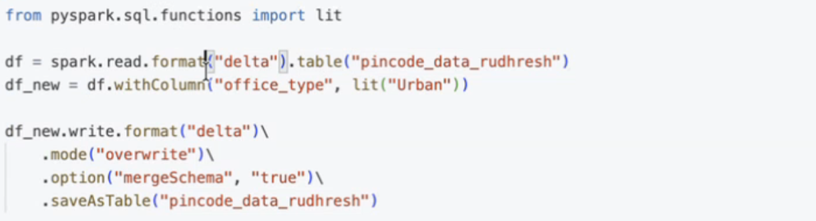

**Day 7**

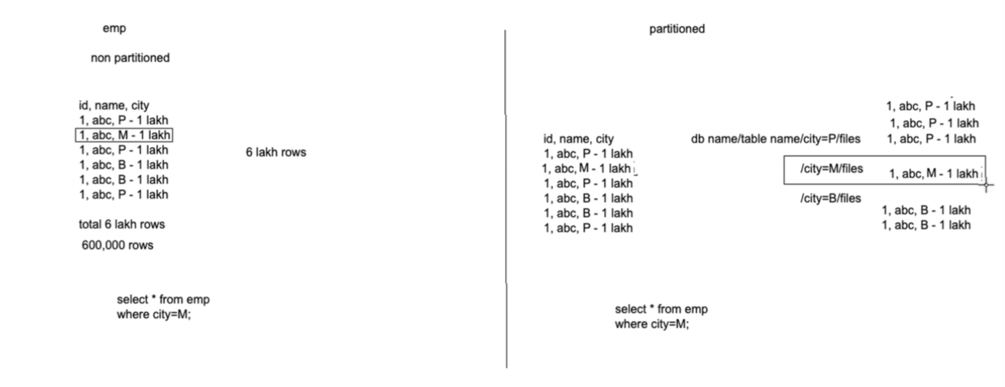





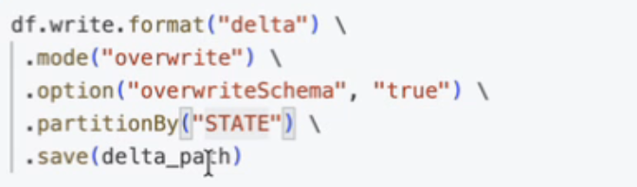



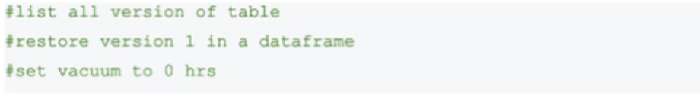

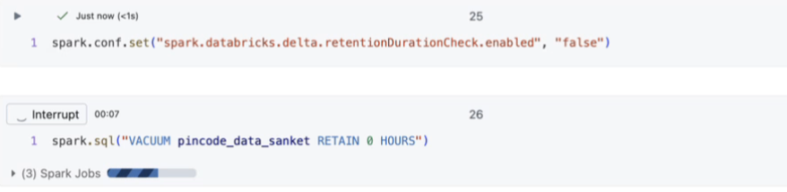

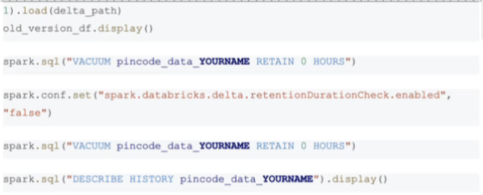

Lab 13: SQL Warehouse

CREATE TABLE ecommerce_data_sanket (

invoiceNo STRING,

stockCode STRING,

description STRING,

quantity INT,

invoiceDate TIMESTAMP,

unitPrice DOUBLE,

customerId STRING,

country STRING

)

USING CSV

OPTIONS (

path 'dbfs:/FileStore/tables/sanket/ecommercedata.csv'

header 'true' inferSchema 'true'

) ;

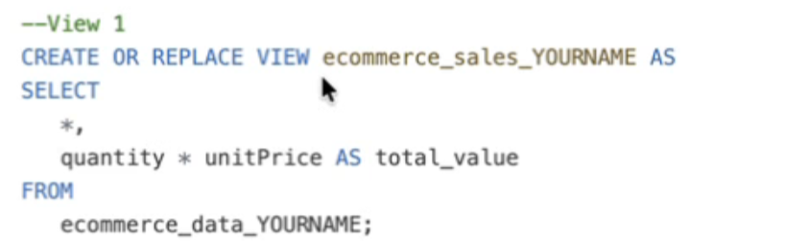

Lab 14: Realtime streaming in Databricks

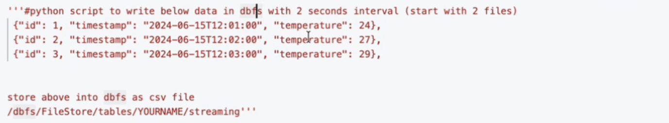

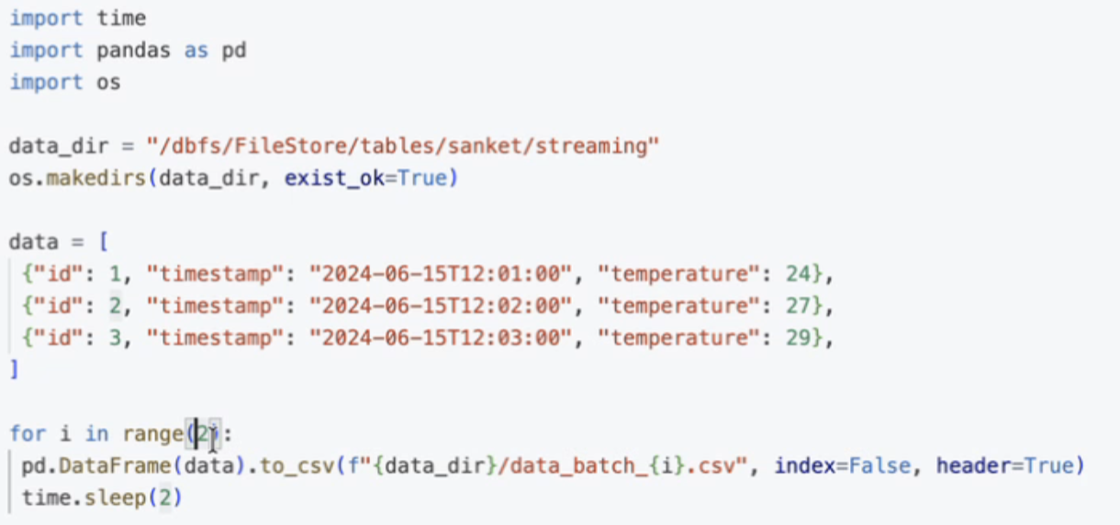

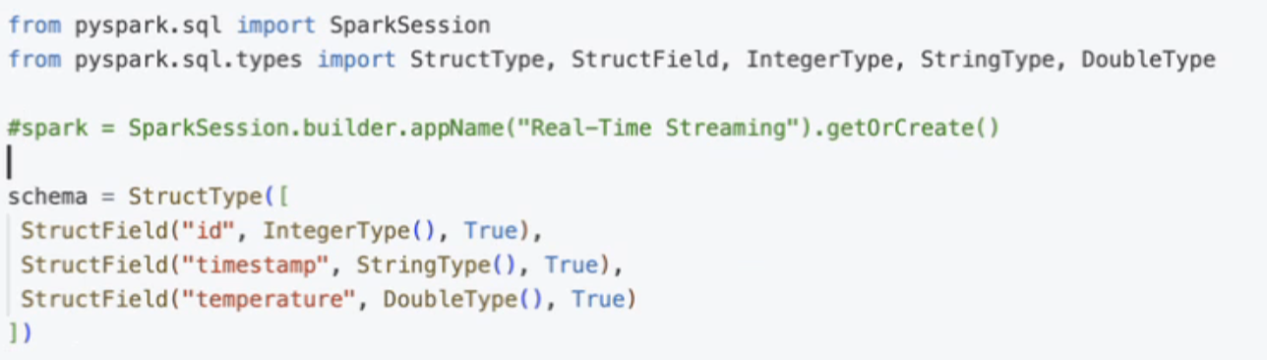

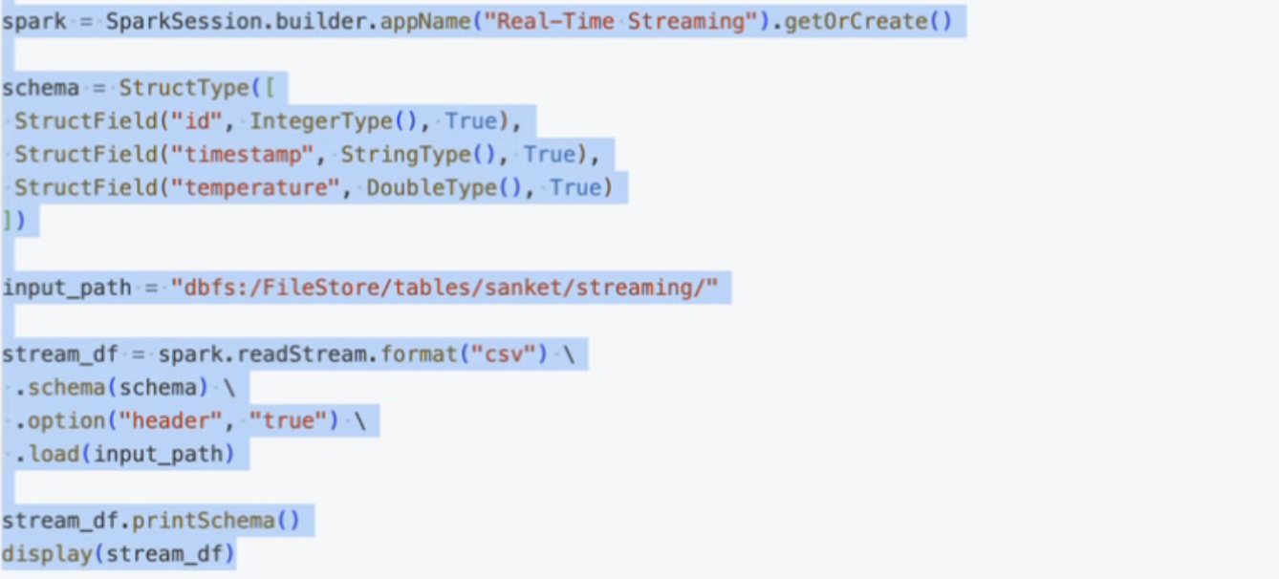

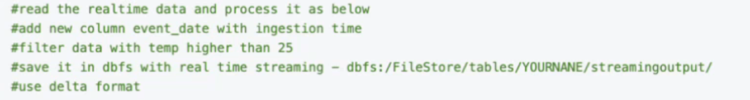

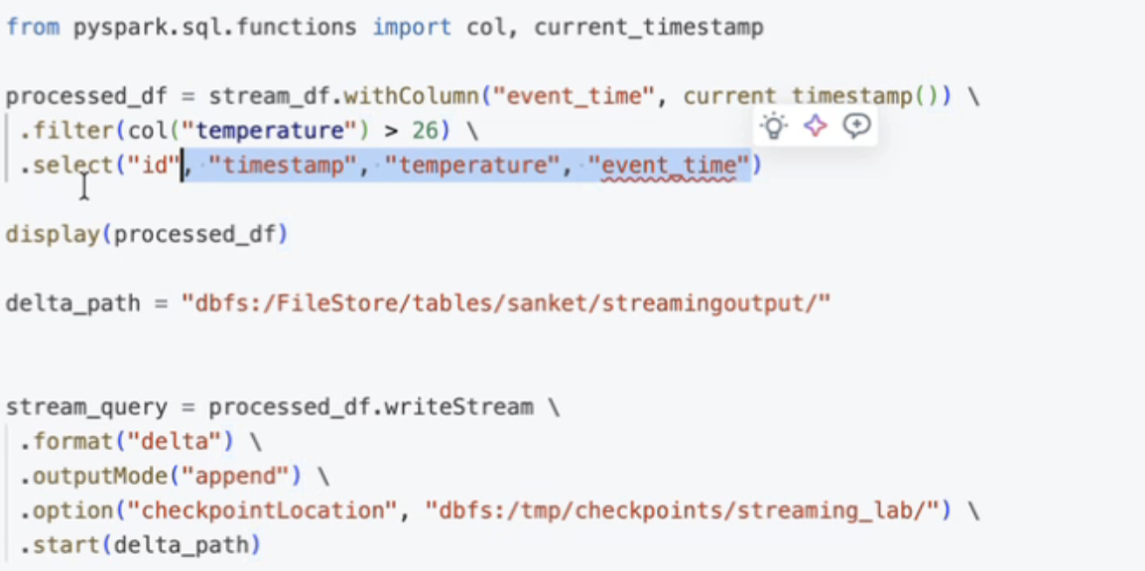

Lab 15: Unity catalog

Lab 16: API Integration

<https://api.open-meteo.com/v1/forecast?latitude=12.9537&longitude=77.3012&hourly=temperature_2m>

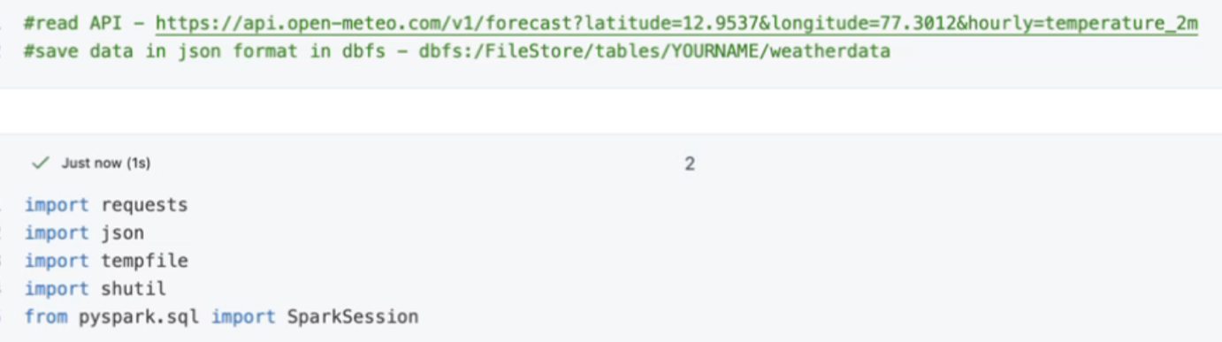

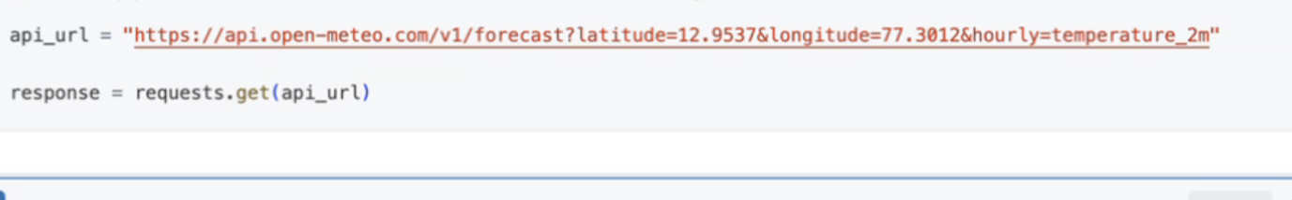

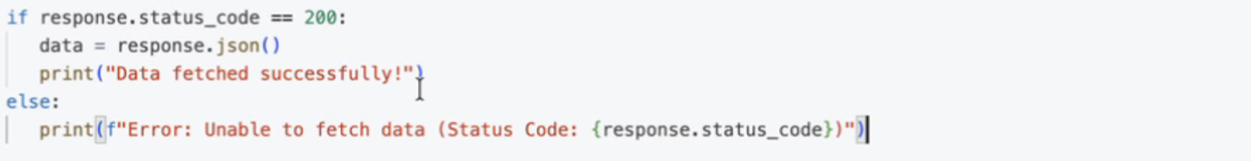

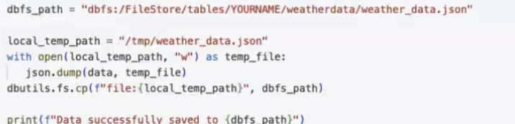

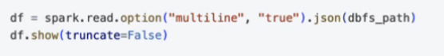

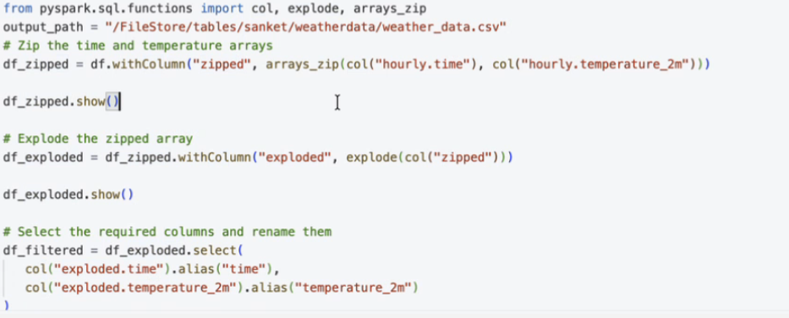

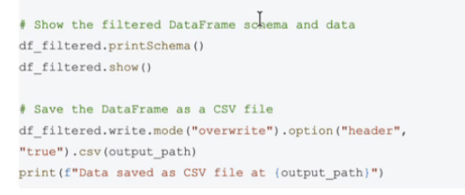

LAB 17 – ML on Databricks

Lab – Capstone Project

1. Task 1 read csv
2. Struct table

